Shabbos Stories for
Parshas mattos-massai 5775
Volume 6, Issue 45 2 Menachem Av 5775/ July 18, 2015
Printed L’illuy nishmas Nechama bas R’ Noach, a”h

For a free subscription, please forward your request to keren18@juno.com
Ghana’s Jews Welcome
Their First Rabbi
By Menachem Posner

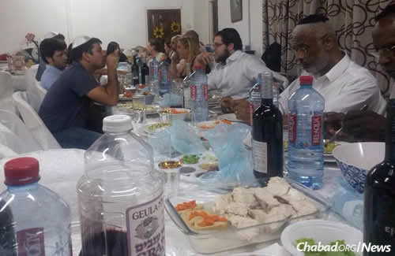
Rabbi Noach Majeski, center right, is the Ghana Jewish community's first rabbi.

Ever since Tami Sasporta moved from Israel to Accra, Ghana, 12 years ago —her husband, Shahar, is involved in road construction—she says Jewish communal life pretty much began and ended with the High Holidays and Passover.
“Each year, Chabad of Central Africa sent two young rabbis,” she explains. “They’d improvise a synagogue, spend a few days before the holiday meeting many Jews as possible, hold educational programs for the children, and then invite everyone for services and meals during the holiday itself.”
For the rest of the year, the Sasportas and families of mostly Israeli expatriates living in the sub-Saharan nation were pretty much on their own Jewishly.
She expects that to change, however, with the imminent arrival of Rabbi Noach and Alti Majesky and their three children, who will be leading a new Chabad center in what will be the latest branch of Chabad-Lubavitch of Central Africa, founded in 1991 by RabbiShlomo Bentolila of Kinshasa, Congo.
In fact, Rabbi Majesky notes that many of the people he has met on two pilot trips there were on first name with Bentolila, even though the French-speaking rabbi rarely has time to visit Ghana in person. Based out of the Democratic Republic of Congo, Chabad-Lubavitch of Central Africa currently operates in 13 countries, including the Congo Republic, Nigeria, Ghana, Angola, Namibia, Gabon, Ivory Coast, Kenya, Uganda, Ethiopia, Mali and Senegal.

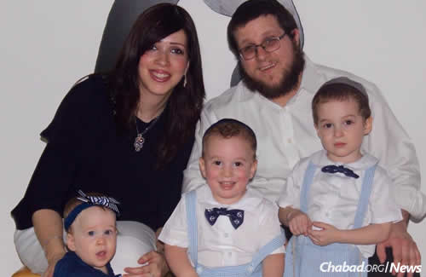
Rabbi Noach and Alti Majesky, and their three children

“There is no doubt,” he says, “that the fact that we are able to open a Chabad center, and that the community is so supportive and receptive is due to the very strong connections that Rabbi Bentolila has established, both personally and through the ‘Roving Rabbis’ who have been coming throughout the decades.”
Discussing the rapid expansion of Jewish life in the region, Rabbi Moshe Kotlarsky, vice chairman of Merkos L’Inyonei Chinuch—the educational arm of the Chabad-Lubavitch movement—pointed out that “Central Africa is renowned for refining its physical resources, and our mission is to refine its bountiful spiritual resources. Torah and mitzvahobservance are thriving in Africa with the continued growth of its Jewish communities.”
Majeski says neither he nor his wife—natives of Brooklyn, N.Y., and Paris, respectively—ever thought they would call an African nation with no more than several hundred Jewish souls home. But then, after a visit to the Ohel in Queens, N.Y.—the resting place of theLubavitcher Rebbe, Rabbi Menachem M. Schneerson, of righteous memory—in which he prayed for direction, he suddenly got phone calls from a number of friends who had seen a notice on an message board for Chabad-Lubavitch emissaries that a position had opened up in a distant location. He soon discovered that location was Ghana.
“I went to visit for Chanukah,” he says, “and I am still amazed by what I saw. There is a beautiful community of young families and singles—mostly from Israel, but also Americans and others—and they are just thirsting for Jewish communal life.
“We had a kids’ program for the holiday, and 40 children attended. We then hosted over 100 people for a Chanukah party,” recalls the rabbi.
The whole family flew in for Passover with 15 suitcases in tow. Three contained personal belongings; the rest were stuffed with matzah, wine and other Passover essentials.
After a round of successful children’s programs, followed by well-attended holiday services and meals, the Majeskys were ready to make Ghana their new home. They plan on settling in the Airport Residential Area, where many of the Israeli families live.
With just a few weeks left until their arrival in Africa, the rabbi says he and his wife are busy planning programs, fundraising, and taking care of the countless odds and ends that come with moving across the globe to a new nation. As for Sasporta, she and her fellow Israeli-Ghanaians are eagerly awaiting the Chabad family’s arrival.
“There is no doubt that there is a positive buzz,” says the mother of three, who has raised her children in both Israel and Ghana. “My friends and I are looking forward to Jewish programs for ourselves and improved Jewish education for our children. And I know that some of the men are very excited about the prospect of having a synagogue—something we’ve never had before.”

Reprinted from last week’s email of Chabad.Org Magazine.
Potential Parah Adumah Disqualified After Giving Birth

Less than two months after Maran Rav Dovid Feinstein, rosh yeshiva of Mesivta Tiferes Yerushalayim in New York, visited Howell, NJ, to get a firsthand look at a possible parah adumah, the cow is no longer suitable to be used as aparah adumah because it has given birth.
The red cow is owned by Mr. Herbert Celler, the owner of Classy Hair Designs, who was offered $1 million for the cow earlier in the year by someone in Brooklyn, but Caller said that she’s not for sale.”
The cow gave birth Wednesday morning [July 1st], rendering it posul to be used as a parah adumah.
The baby, a black calf, is said to be doing well, as is its mother.
The potential parah adumah was born on April 2, 2013, during Pesach. Celler was extremely vigilant over the past two years to make sure that the cow did not engage in any work or sustain any blemishes, which may have disqualified the cow according to halacha.
The parah adumah gained attention around the world after first being reported on here at Matzav.com half a year ago, when the cow was three months shy of its second birthday.
Suprisingly, Celler told Matzav.com, he was not aware that the cow was expecting a baby.
“We had no idea,” he said. “It caught us by surprise.”
A child of Holocaust and concentration camp survivors, Celler, who grew up in Lakewood and attended the local Betzalel Hebrew Day School, graciously opened his farm over the past half year to allow almost 40,000 people to view the cow.
Celler is obviously very disappointed about the disqualification of his cow, but he says that it must be a sign from Heaven that Klal Yisroel is not yet ready for it.
“Hashem is saying that His nation is not ready at this time. He’s ready, but we are not,” he said.

Reprinted from the July 5, 2015 website of Matzav.com.{Dov Green-Matzav.com Newscenter}

Morocco to Rehabilitate Ancient Jewish Quarter of Marrakech

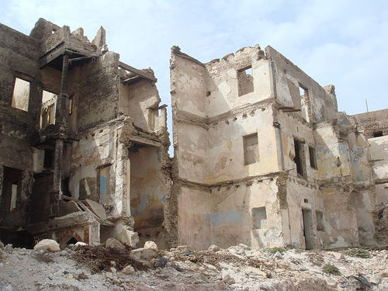
Remnants of the Jewish quarter of Marrakech. Credit: World
Imaging via Wikimedia Commons.

(JNS.org) Morocco plans to rehabilitate the ancient Jewish quarter of Marrakech in an effort to boost tourism to the city.
Morocco World News, citing the Moroccan French-language newspaper L’Economiste, reported that the conservation plan is part of a jointly financed project by the country’s Housing Ministry and city of Marrakech. The project will cost around $20 million as part of larger $32 million rehabilitation of Marrakech’s old city.
The project in the ancient Jewish quarter—which is known as the “Mellah” and was built in the 16th century by Jews escaping the Spanish Inquisition—will include plans to safeguard houses that are threatened with collapse, the rehabilitation of homes, and some demolition of properties.
Morocco was once home to more than 250,000 Jews, many of whom immigrated to Israel in the mid-20th century. The former Jewish quarter in Marrakech is now occupied by Muslims. Recent efforts have been made by Morocco to protect its Jewish history and to encourage Jewish tourism.
In 2013, the Moroccan government finished a two-year restoration project for the Slat al-Fassiyine (Prayer of the Fesians) synagogue in the historic city of Fez.

Reprinted from the June 25, 2015 email of JNS.org

Story #919

The Shabbat of
Missed Opportunity
From the desk of Yerachmiel Tilles
editor@ascentofsafed.com

Once during his travels, Rabbi Aharon of Karlin arrived at the town of Zarowitz close to the Shabbat. He saw a small cottage situated on the edge of the town and he knocked on the door, hoping to find some hospitality there. A small woman opened the door and listened to his request to remain there for the Shabbat. "You are welcome to stay," she replied simply, â€œmy husband, will be home soon,â€ and she ushered him into the house.
As soon as he set his foot inside the door, Rabbi Aharon felt himself enveloped by an overwhelming sense of holiness, and he realized that there must be something unique about the occupants of this house. R. Aharon prepared himself for the Shabbat and was about to go out the door to the synagogue when he met Reb Yitzchak, the owner of the house, just returning from his workday. The man was dressed in simple peasant garb, and there was nothing to distinguish him from any other worker. He introduced himself as Yitzchak and greeted his guest warmly, but his features disguised any emotion.
Aharon of Karlin was accustomed to celebrate the Shabbat with enthusiastic singing and prayers, and he followed his usual rituals. His host, however, rushed quickly through the prayers, hurriedly said kiddush over the wine and then sat down to eat his simple meal. But even in this plain food, R. Aharon could detect an undeniable holiness, although he couldn't figure out what it stemmed from. He studied the man and woman, but there was nothing special about anything they said or did that would set them apart from any of ten thousand other poor Jews.
When the Shabbat ended R. Aharon thanked his host and hostess and continued on his journey, the mystery unsolved.

******************

The following week, a woman turned up in the Study Hall of the nearby city of Premishlan and spoke to the members of the local burial society requesting that they come with her. "Please come with me to Zarowitz now, for my husband is dying and he has asked that you be with him in his last moments."
The men immediately followed her to her home, but when they entered the house, her husband wasn't even there. "What is this, some kind of joke? Have you brought us all this way for nothing?"
"No, of course not, gentlemen," she replied. "My husband is on his way and will be here shortly."
Shortly after, her husband walked through the door, holding a bunch of straw. He spread the straw on the floor and laid down upon it, on his back. Then he began speaking to the burial society officials:
"My friends, it is now time for me to leave this world. I have lived a secret life as a hidden tzadik (perfectly righteous person) all my life, but the time has come for me to reveal myself. The moment that I die, go with all speed to Premishlan and bring back as many scribes as you can gather. Have them bring pens and paper, for here they will copy over my secret writings. This must be done while I am still lying here on the ground, before I am buried. Watch me, and when you see a change in my face, all writing must cease at once."
R. Yitzchak finished speaking, closed his eyes, and for a moment his face burned like a fire. Then, his lips which had been moving in silent prayer became still, and he was gone.
Scores of scribes were hurriedly brought to the cottage where the tzadik lay. Each one was given a leaf of paper to copy and they raced against time to complete their holy task. The officials' eyes were fixed on the face of the tzadik, looking for any change. Suddenly, the face lost all of its color and the box which contained his writings mysteriously closed by itself. The scratching of pens stopped abruptly, and preparations were quickly begun to ready Yitzchak the tzadik for burial.

******************

When Rabbi Aharon of Karlin heard of the death of the tzadik and the circumstances which surrounded it, his heart was filled with bitter regret. What wondrous Torah secrets he might have learned from the deceased! He went to pay his respects to the widow and perhaps to glean some bit of knowledge from her husband's secret life.
"Well, there's nothing I can really tell you," she said. "I'm sorry, but my husband wouldn't permit it."
R. Aharon was bitterly disappointed. He wished her comfort, among all the mourners of Zion, and turned to leave. But just as he reached the door, the widow called out to him, "Wait, there's one small thing I can show you. Do you see those candlesticks there on the shelf? Well, from the day I married until the day my husband died, the candles that were lit in them burned constantly, all by themselves."
Rabbi Aharon left the cottage deep in reflection. The wondrous accomplishments of the hidden tzadik would remain one of G-d's many secrets, perhaps to be divulged only by Mashiach, himself.

*************

Source: Supplemented by Yerachmiel Tilles from the rendition on //lchaimweekly.org (#1014).
Biographical note: Rabbi Aharon ("the Great") of Karlin; (1736 - 19 Nissan 1772) was a disciple of Rabbi Dov Ber of Mezritch. He was the pioneer of Chasidism in Lithuania, as is evidenced by the fact that in contemporary sources, "Karliner" was a local synonym for "chasid". He is remembered for the ecstatic and unrestrained fervor of his prayer, for his solicitude for the needy, and for the moral teachings embodied in his Azharos ("Warnings"). He was succeeded by his disciple Rabbi Shlomo of Karlin (1738 - 22 Tammuz 1792), after whose death the succession reverted to R. Aharon's orphaned son, Rabbi Asher of Stolin (1762 - 1826), who had been sheltered and educated by R. Shlomo since the age of 12. The dynasty still thrives today; the Chasidim are known for the volume of their communal prayers.
Connection: Seasonal--192ndyahrzeit of Rebbe Shlomo of Karlin.

Reprinted from a recent email from Ascent of Safad in Israel.

The Diamond Merchant
Adapted by Dovid Shraga Polter

During his visit to New York in 1930, the Previous Rebbe stayed at the newly opened Roosevelt Hotel. Crowds of Jews gathered outside the hotel each day, hoping to see the Rebbe and request a blessing.
One morning, two young, wealthy businessmen were passing by and asked why the crowd had gathered. When they heard that a holy Rabbi from Europe was visiting and giving out blessings, they joked that the old Rabbi just wants their money.
To prove their theory, they joined the waiting crowds to see if they would be called sooner than the others since they appeared to be wealthy and dignified. Meanwhile, the Rebbe’s secretary, Rabbi Eli Yechiel Simpson, “was making his rounds,” inquiring about each person’s reason for seeing the Rebbe.
Sure enough, within minutes, they were called to the front of the line! As they were ushered into the Rebbe’s room, the pair smirked — pleased to have been so quickly proven right.
The Rebbe asked the businessmen to sit, and before they could say a word, he began: “You’re probably wondering why I asked to see you before those who have been waiting longer. You see, many of these people want a blessing for health. But I’m not a doctor, and to bless them with good health is a strenuous task. Likewise, others want me to bless their business endeavors. But I’m not a businessman; I never studied economics, and giving the correct blessing is quite taxing.
“But when I heard that there were two young Jews wanting to know how one can be religious in America, I said, ‘Here we go! This is precisely my area of expertise. Please send them right in.’”
“What area of business are you in?” asked the Rebbe.
“We are diamond merchants,” they replied.
“What is your profit margin?” the Rebbe asked.
“We have a 100% markup rate.”
“And if someone were willing to pay only 20%, would you still make the deal?”
“Yes,” the men replied.
“What if the same person came back the next day? Would you again take the 20%?”the Rebbe asked.
“Of course not!” the businessmen explained. “We would try again to get the full price.”
“That,” concluded the Rebbe, “is the secret to being Jewish in America. It’s easy to be 20% observant and feel comfortable with that. But it’s important to remember the 100% and strive for it.”
Now, we’re only human, and sometimes we’ll only get to 20% — certainly better than nothing because it’s still a profit. But the next day, we have to strive for 25%, then 30%, and so on until we’re closer to 100%. Keeping our eye on the prize — the 100% — will keep us motivated and inspired.

Original translation by Rabbi Mordechai Lipskier who heard it from Rabbi Berel Futerfas

Reprinted from last week’s email of Chabad.Org Magazine.

The Unfinished Diary:
A Chronicle of Tears
A rare Holocaust diary appears 70 years
after being written by its doomed author.
By Chaim Yitzchok Wolgelernter, Hy”d

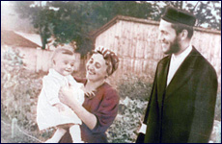
As he sat crouched in a foul-smelling cowshed and hayloft for months on end, with nothing but his own bleak thoughts to keep himself occupied, Chaim Yitzchok Wolgelernter turned to his pen as a means of endurance. An unusually gifted writer, this young husband and father of two made it his goal to chronicle his Holocaust experiences as they were occurring.
And so, as he wandered the countryside from hideout to hideout, worrying about the fate of his family members who were also on the run, Chaim Yitzchok wrote. And as he hid in a dilapidated mikveh building together with his terrified younger brothers, Chaim Yitzchok wrote some more. And as he sought refuge in the barn of a Polish woman, who would eventually turn her back on him, Chaim Yitzchok continued to write.
The result: a personal Holocaust journal with a rare level skill apparent in each chapter chronicled by the author.
Unfortunately Chaim Yitzchok did not survive the inferno of the Holocaust; he was brutally murdered just a few months before liberation. His diary, though, did survive. It was rescued by his brother and eventually made its way to North America, where it lay in a drawer, untouched, for many years.
In the meantime, Chaim Yitzchok’s surviving child, Feivel, grew up, married, and had children of his own. His son, Nafti Wolgelernter, was the one who pushed for his grandfather’s diary to be deciphered and translated so that the family could connect with Chaim Yitzchok’s writings.
What followed were many years of meticulous work and effort, and now, 70 years after being written, this fascinating diary is finally being brought to light, released in English to the public.
This rare, historic work can be appreciated at many levels. Each page reveals an astounding depth of emotion, coupled with a cynical, witty – at times, even humorous – literary style. The diary is breathtaking in its eloquence and scope, heartbreaking in its descriptive account of the travails suffered by the author and his family. It reveals shocking details on the reaction of the local Polish populace to the unfolding disaster. Given its unique perspective, this compelling account lends an entirely new dimension to the world of Holocaust literature.

The following excerpt from The Unfinished Diary illustrates just one of Chaim Yitzchok’s brushes with death during his time spent in hiding and on the run.
My Miraculous Escape
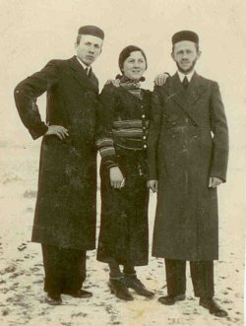
(l-r) Meir, Yitta, Chaim Yitzchok
At midday, I continue on. In order to avoid the main road where wagons travel, I walk through the village of Drozejowice. I am almost at the far end of the village when I hear a vehicle approaching at high speed. Turning around, I see two German army wagons. They must be the same ones that were in Szyszczyce last night, heading back from Dzialoszyce for a second round.
In a flash, I am in the fields looking for a place to hide. But no more than twenty meters behind me, one of the soldiers chases me on foot.
"Halt!" he shouts.
When I do not stop, a shot rings out.
As I continue running, I notice a peasant woman coming out of a little farmhouse with a burnt roof, closing the door behind her and bolting it with a chain – a sure sign that no one remained at home.
I stretch out flat on the floor, quickly cover myself with the straw and lie there holding my breath, fearing the worst.
Without a moment to lose, I race over to the house, silently remove the chain and enter the front room. Seeing a ladder standing there, I climb up, ducking down to make sure no one can spot me from the outside through the exposed roof.
There is a thick layer of straw in the attic, protecting the house from rain. I stretch out flat on the floor, quickly cover myself with the straw and lie there holding my breath, fearing the worst. Barely do I finish throwing the last piece of straw on myself when the door of the house is thrown open.

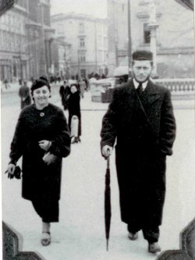
Chaim Yitzchok and Chayele Wolgelernterin Krakow, late 1930s

The German soldier enters, looks around for a few minutes, then leaves. A moment later, he comes back in and starts climbing up the ladder. This is it… I am doomed. He stands in the attic for a short while, scanning it carefully, then goes back down.
I hear many loud voices outside. It seems all the soldiers are looking for me. Straining my senses, I peek out from beneath the straw and see the peasant woman being led by the arm.
"Where is the fellow who escaped from us?" they interrogate her. "Where is he hiding?"
She has no idea what they are talking about.
"Kreuz-Donnerwetter!" they shout, slapping her. "If you don't tell us, we'll burn down your house!"

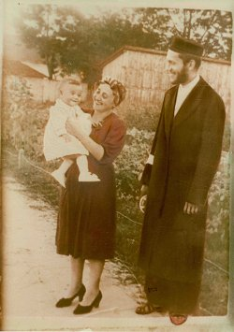
Chaim Yitzchok and Chayele with their firstborn child,
autumn 1940; note white armband on sleeve

I am in grave danger. O Merciful God! I pray. It is not yet three months since I was orphaned of my parents. Shall my two-year-old son, my one remaining child, now become orphaned, too, of a father whom he hardly knows? If I perish here in the fields of Drozejowice, there will be no witness to my death, and my dear Chayele will remain a tormented agunah for the rest of her life.
Tomorrow night is our seventh anniversary. Shall our happy married life come to such a tragic end?
Today, the eighth of Adar, is the yahrzeit of my grandfather Rav Yechiel Issamar. Zeide! For whom have I undertaken this dangerous trip if not for my brothers, the children of our exalted father, your son Yeshayah! Shall your yahrzeit, a day when the soul rises to a loftier realm, be stained by the blood of your murdered son's child?
After all, I am only living for my wife Chayele, for our one and only innocent little child, and for my rescued brothers who have not yet experienced happiness. Shall the hands of the murderers succeed in destroying all these lives at once? I want to live to avenge the blood of my parents and sister…!
At that moment, I made a decision: I would not fall into their hands alive! Taking out the razor blade I carried on me, I held it close to my throat and observed the ensuing events.

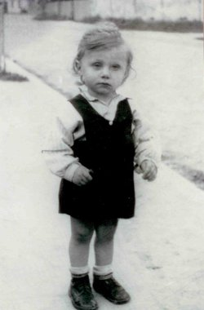
Feivel Wolgelernter, about one year old,beginning of 1942

The peasant woman crossed herself and swore by all her saints that she knew nothing. I saw one soldier hold her to make sure she did not escape, while the others tossed straw and grain out of the adjacent barn. "He's got to be hiding right around here!" I heard one German shout.
I am still in great danger…they may decide to come up here again.
I watch as several soldiers move on to search the neighboring houses. A few continue to stand outside, holding onto the woman. I feel like my eyes are popping out of their sockets. How long the search lasts, I cannot determine.
The soldiers return, unsuccessful.
"It can't be!" I hear one of them insist. "He must be here somewhere!"
Not only do I see death before me but I already feel it; every one of my limbs has gone numb.
Again, they begin to flog the peasant woman, threatening to demolish her house. By now, not only do I see death before me but I already feel it; every one of my limbs has gone numb.
Suddenly, it grows quiet: one minute, two, three…
I peek out again from under the straw. I do not see a soul. My heart slowly resumes beating. I wait a bit more…I do not hear a thing. I wait for what I estimate to be half an hour…still quiet. Then, I hear the crack of a whip. The wagons must be leaving. With G-d’s help, the danger has passed.
I lie motionless in the attic until it becomes pitch dark; I cannot be sure they haven't left one of their men behind. Then I climb down the ladder, approach the woman and ask her what happened.
With tears in her eyes, she tells me the whole story.
"Are you sure they are gone?" I ask her.
"They did not leave anyone behind," she assures me.
"I am the one they were looking for," I inform her, offering her some money. After all, it was because of me that she received a beating.
She declines. "Thank the good Lo-d, I am glad that I truly did not know you were up there!" she says. "This way a person was saved through me. I do not want a reward for that." She would not even tell me her name.
The next morning, back in the loft in Skalbmierz, Magda relayed the conclusion of the previous day's events, which she had heard from a Drozejowice villager.
The Germans barged into a house where some young peasant boys were playing cards. Identifying one of the boys as the supposed escapee they were searching for, they beat him savagely, forcing him to confess why he had run away.
The fellow remained unconscious for four straight weeks.

This excerpt from “The Unfinished Diary: A Chronicle of Tears” by Chaim Yitzchok Wolgelernter, Hy’d was reprinted from last week’s website of Aish.com The book is available in Jewish bookstores or by contacting the publisher by calling (888) 536-7427 or clicking www.israelbookshoppublications.com

